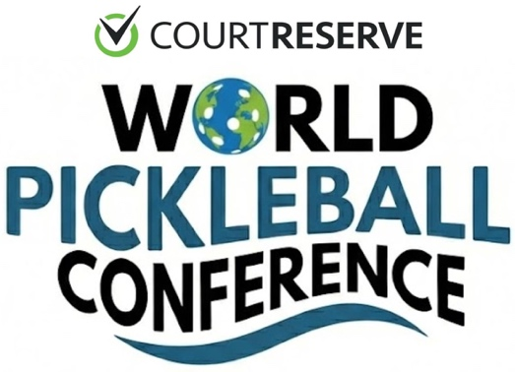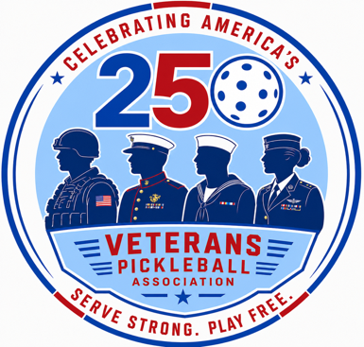

Veterans Pickleball Association (VPA) announces
Celebrate America 250 with Paddle Battle of the Branches
During July CourtReserve World Pickleball Conference in Las Vegas

FOR IMMEDIATE RELEASE MAY 11, 2026
MEDIA CONTACT: CARL FOSTER 561.440.0941

BOCA RATON, FL (May 1, 2026) The Veterans Pickleball Association, Inc, (VPA), a 501c3 non-profit charity since 2024, announced their plans today to celebrate America’s 250th birthday celebration July 16-18th in Las Vegas at the new ChickenNPickle Henderson with a Paddle Battle of the Branches and Pro-Celebrity Exhibition fundraiser.

The VPA launched in 2024 with a mission to honor our veterans and continue to enrich the physical, mental and competitive lives of Veterans, Wounded Warriors, Paralyzed and Court Adaptive Vets plus Purple Heart Combat recipients and their family members through the sportsmanship, camaraderie and lifestyle of the fastest growing sport in the world…PICKLEBALL.

“We are excited to partner with the COURT RESERVE World Pickleball Conference (WPC) for a 3-day event and return to Las Vegas area bringing out veterans of all branches of service to compete in our first Paddle Battle of the Branches in the Armed Forces Pickle Bowl on Thursday, July 16th FROM 6-9PM at the new ChickenNPickle in Henderson, Nevada,“ stated Carl Foster, USAF Vietnam Veteran and founder of the VPA and VPA Tour.

Foster added, “We are planning wheelchair and adaptive exhibitions, a Celebrity Pro-Am with top Pickleball Pros and Professional athletes from other sports integrating with the veterans. There will also be free clinics on site introducing first time veterans to the sport.”

Veteran owned businesses will also be featured with over 40 business leaders during the two-day WPC with keynote topics and panel sessions tackling the key issues and growth of the billion dollar pickleball industry. Achievers, visionaries and performance minded executives with many also Veterans will be live on stage at the CNP Henderson July 17-18th. More information on the WPC is available at: www.WorldPickleballConference.com

Over 100 of the most influential pickleball business owners, CEOs, top players/athletes plus high level executives have spoken live on stage the past 3 years at WPC events including names like: Steve Kuhn, Kyle Yates, Pran Kohli, Dave Weinbach, Lee Whitwell, David Johnson, Will Richards, Ashley Owens, Rick Barry, Ace Rodgriguez, Ted Angelo, Jorge Barragon, Tito Machado, Gordon Kaye, Justin Maloof, Javier Regalado, Chandler Carney, Stephanie Russell, Carl Schmits, Beth Bellamy, Rick Witsken, Sam Flaxman, Doug Mauch, Curtis Smith, Rene Prats, Ray Colaiacovo, Robyn Duda, Dr. Rommie Maxey, Paul Olsen, Hercilio Cabieses, Brad Tuckman, Zach Hunter, Mike Dilecce, Dr. Stewart Davis, Seymour Rifkind, Dr. Joy Macci and more.

George Domaceti, a USN Special Services Purple Heart veteran, and founding VPA Board member added, "I am thrilled to join long time friend, business partner and fellow veteran, Carl Foster, in expanding our pickleball businesses with the October 6th World Pickleball Convention & Conferences incorporating the VPA Tour. This is a perfect way for us to be able to offer our fellow veterans and first responders worldwide their own competitive platform from beginner to professional, male or female, and all skill levels.

Foster also stated, “We will be utilizing over four decades of sports event management experience and relationships, hosting and producing national broadcast television programs, operating world leaders and pickleball conferences to build a legacy of servant leadership by creating a physical and mentally healing platform for our veterans and first responders with Pickleball.”

About the Veterans Pickleball Association (VPA) and VPA Armed Forces Tour
The VPA mission is to enrich the physical, mental and competitive lives of Veterans, Wounded Warriors, Purple Heart Combat recipients and their family members through the sportsmanship, camaraderie and lifestyle of the fastest growing sport in the world…PICKLEBALL. The VPA is a 501c3 membership based association that will sanction and host qualifying events to give members the chance to compete at pickleball events nationwide and the annual VPA Tour Armed Forces Pickle Bowl National Championships. More info available at: www.VeteransPickleballAssociation.org or Contact: Carl Foster at 561.440.0941.

